**Assignment 6 – Part 2  
Set 5.9 - 6, 10, 13.b, 16**

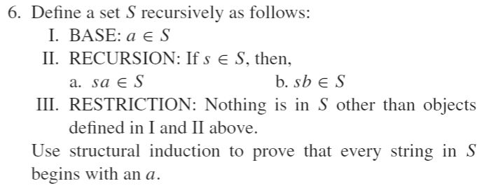  
**The only object in the base for $S$ is $a$, which begins with an $a$.  
The recursion for $S$ consists of two rules denoted II(a) and II(b). When rule II(a) is applied to the base the result is $aa∈S$, which begins with an $a$. Rule II(a) can be applied over and over and the result will always begin with an $a$. Similarly, rule II(b) applied to the base results in $ab∈S$, which also begins with an $a$. Rule II(b) can also be applied over and over with the result always beginning with an $a$.   
Because no objects other than those obtained through the base and recursion conditions are contained in $S$, it must be the case that every object in $S$ satisfies the property that every string begins with an $a$ [what we needed to show.]**

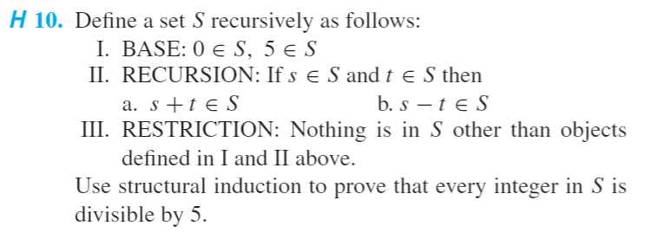  
**The base objects of $0∈S$ and $5∈S$ are both divisible by 5.  
The recursion for $S$ consists of two rules denoted II(a) and II(b).   
By II(a), $$0+0∈S, 0+5∈S, 5+0∈S, and 5+5∈S$$  
These sums are all divisible by 5. If we were to keep adding up these sums, we would always get a result divisible by 5.  
By II(b), $$0-0∈S, 0-5∈S, 5-0∈S, 5-5∈S$$ 
These differences are all divisible by 5. If we were to keep subtracting these differences, we would always get a result divisible by 5.  
Because no objects other than those obtained through the base and recursion conditions are contained in $S$, it must be the case that every object in $S$ is divisible by 5.**

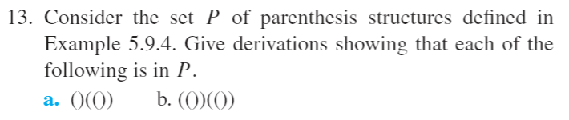  
**(1) By I, () is in P.  
(2) By (1) and II(a), (()) is in P.  
(3) By (2), (1), and II(b), (())(()) is in P.**

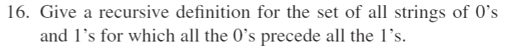  
**I. BASE: $λ$ is in $S$, where $λ$ is the null string.  
II. RECURSION: If $s∈S$, then  
 (a) $0s∈S$ and (b) $s1∈S$,  
 where $0s$ and $s1$ are the concatenations of $s$ with $0$ and $1$ respectively.  
III. RESTRICTION: Nothing is in $S$ other than objects defined in I and II above.**